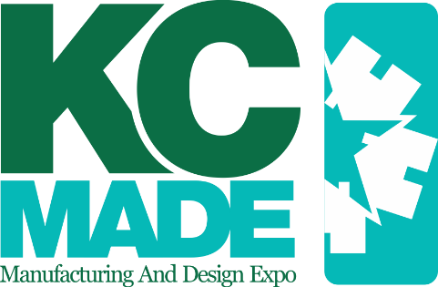

Registration Checklist

In your registration, please be sure to include the following:
- Project Entry Forms (Group & Individual)
- Summary Sheet
  - Must be signed by CTE instructor.
- Check for Total Project Entries
  - Checks must made out to KCHBA. Personal checks will not be accepted; all checks must be provided by the educational institution.
- Student and Industry Luncheon Registration link sent to parents that have a student participating in KC MADE.

Completed registration forms and checks must be mailed to:
Courtney Reyes
Home Builders Association of Greater Kansas City
600 E 103rd St
Kansas City, MO 64131

Entries must be postmarked by Friday, February 7, 2020.

For any questions please contact:
Courtney Reyes
Government Affairs & Workforce Development Director
Courtney@kchba.org
816-733-2214

